# 

# **SAVEETHA INSTITUTE OF MEDICAL AND**

# **TECHNICAL SCIENCES CHENNAI – 602105**

**CAPSTONE PROJECT REPORT**

# TITLE

**Server less Computing Application**

***Submitted to***

# SAVEETHA SCHOOL OF ENGINEERING

***By***

## MOHIT TEJ (192210395)

***Guided by***

## Dr. J. Chenni Kumaran.

Server less Computing Application

This document serves as a comprehensive guide to server less computing, exploring its fundamentals, benefits, and practical applications. We'll delve into the core concepts of server-less architecture, examine popular platforms, and provide insights into developing and deploying server less applications.

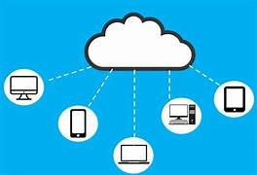

# Benefits of Serverless Architecture

**1.Cost Optimization**

Server less computing eliminates the need for provisioning and maintaining servers, leading to significant cost savings. You only pay for the resources used, making it an attractive option for businesses of all sizes.

**2.Scalability and Elasticity**

Server less platforms automatically scale resources up or down based on demand. This ensures seamless performance, even during peak traffic periods, without manual intervention.

**3.Increased Developer Productivity**

Serverless architectures simplify development work flows. Developers can focus on writing code without worrying about server management, infrastructure setup, or scaling.

**4.Faster time to Market**

Serverless deployments are typically faster than traditional methods, allowing businesses to launch applications and features more quickly and respond to market changes agilely.

**Serverless Computing Platform**

**Platforms:**

1. AWS Lambda.
2. Azure Functions.
3. Google Cloud Function.
4. Netlify functions.

**Provider:**

1. Amazon Web Service.
2. Microsoft Azure.
3. Google Cloud Platform.
4. Netlify.

**Key Features:**

1. Scalable, cost-effective, event- driven, integrates with other AWS services.
2. Flexible deployment options, seamless integration with Azure services, support for multiple languages.
3. Highly scalable, integrates with other GCP services, supports a wide range of languages.
4. Easy to use, serverless functions built into the platform,ideal for front end development.

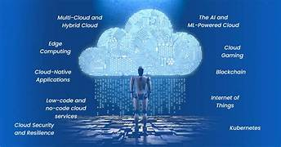

**Serverless Functions and Event-Driven Triggers**

Serverless functions are small, self-contained units of code that execute in response to events. They are stateless, meaning they do not retain data between invocations. Event-driven triggers initiate the execution of serverless functions. Common event types include:

1. HTTP Requests.
2. File upload.
3. Database changes.
4. Message queue events.

**Serverless Database and Storage Solutions**

Serverless platforms offer a range of database and storage options to suit different application needs. Popular choices include:

1. Amazon DynamoDB.
2. Google Cloud Firestore.
3. Azure Blob storage.
4. Google Cloud Storage.

# Serverless Security Considerations

Security is a paramount concern in server less environments. It's essential to implement appropriate security measures, including:

1. Authentication and authorization.
2. Data encryption at rest and in transit.
3. Secure Code Practices.
4. Vulnerability scanning and patching.

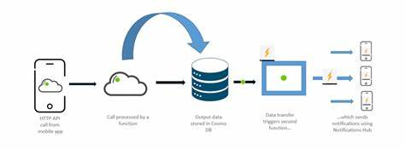

**Conclusion:**

Serverless computing represents a significant paradigm shift in cloud computing, providing a way to build and run applications and services without the need to manage infrastructure. It offers numerous benefits, such as cost efficiency, automatic scaling, and reduced operational complexity. By abstracting the underlying server management, developers can focus on writing code and deploying applications faster, responding to business needs more effectively.

Applications of serverless computing span various domains, including web applications, mobile back-ends, IoT applications, data processing tasks, and more. It allows organizations to innovate quickly, scale efficiently, and improve time-to-market for new features and services.

However, serverless computing also presents some challenges, such as cold start latency, vendor lock-in, and the need for new monitoring and debugging tools. As the technology matures, these challenges are being addressed, making serverless a viable option for a broad range of use cases.

Overall, serverless computing is an exciting and rapidly evolving field that holds great promise for the future of software development and cloud computing.

**References:**

**1.Amazon Web Services (AWS) - What is Serverless Computing?**

URL: [AWS Serverless Computing](https://aws.amazon.com/serverless/" \t "_new)

**2.Microsoft Azure - Serverless Computing**

URL: [Azure Serverless Computing](https://azure.microsoft.com/en-us/solutions/serverless/" \t "_new)

**3.Google Cloud Platform (GCP) - Serverless Computing**

URL: Google Cloud Serverless Computing

**4.Serverless Architectures" by Mike Roberts**

URL: Martin Fowler

**5.Building Serverless Applications" by AWS**

URL: AWS Whitepaper

**6.Serverless Computing: Economic and Architectural Impact" by Eivy, A.**

URL: [IEEE Xplore](https://ieeexplore.ieee.org/document/7958862" \t "_new)

**7.Serverless Computing: A Survey of Opportunities, Challenges, and Applications" by Jonas, E., et al.**

URL: [arXiv](https://arxiv.org/abs/1906.01983" \t "_new)

**8.Serverless Computing: Economic and Architectural Impact" by Eivy, A.**

URL: [IEEE Xplore](https://ieeexplore.ieee.org/document/7958862" \t "_new)

**9.Serverless: Migrating to the Cloud the Agile Way" by Toby Roberts**

ISBN: 978-1788478191

**10.Designing Data-Intensive Applications" by Martin Kleppmann**

ISBN: 978-1449373320

These resources provide comprehensive information about serverless computing, its applications, benefits, and challenges, as well as practical guides for building and deploying serverless applications.